Assignment 2:

1. Paste the link to your github directory here

https://github.com/yavuzbehic/lab-figma-2-220706001/

1. Design the following app in Figma

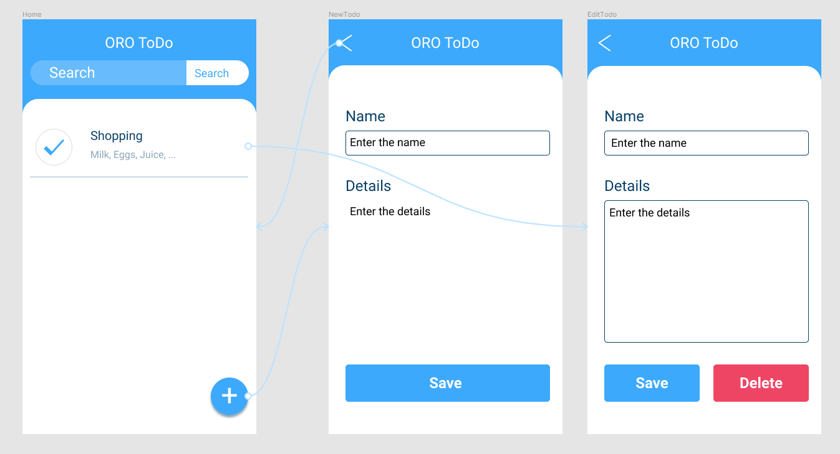

Give the app title the name your_initials ToDo

At the home page

* When to do item is clicked, it should open the edit page
* When the plus sign is clicked, it should open the new page

At the new todo page

* When the < button is clicked, it should go to Home page
* When the save button is clicked, it should go to home page

At the EditTodo page

* When the < button is clicked, it should go to Home page
* When the save button is clicked, it should go to Home page

1. Take a screen capture of each page and the links between pages, paste them in a word document, put it in your github directory you created for this course.

My screen captures:

